| Cybersecurity |
| --- |
| Project 1 Technical Brief |

Make a copy of this document before you begin. Place your answers below   
each question. This completed document will be your deliverable for Project 1. Submit it through Canvas when you’re finished with the project at the end of the week.

## Your Web Application

Enter the URL for the web application that you created:

| https://zantan.azurewebsites.net/ |
| --- |

## Day 1 Questions

### General Questions

1. What option did you select for your domain (Azure free domain, GoDaddy domain)?

| Azure free domain |
| --- |

1. What is your domain name?

| zantan.azurewebsites.net |
| --- |

### Networking Questions

1. What is the IP address of your webpage?

| 20.48.202.168 |
| --- |

1. What is the location (city, state, country) of your IP address?

| [Toronto, Ontario, Canada](https://www.google.com/maps/search/Toronto,%20Ontario,%20Canada) |
| --- |

1. Run a DNS lookup on your website. What does the NS record show?

| 20.48.202.168For CNAME  waws-prod-yt1-057-4c85.canadacentral.cloudapp.azure.com.  ← waws-prod-yt1-057.sip.azurewebsites.windows.net. |
| --- |

### Web Development Questions

1. When creating your web app, you selected a runtime stack. What was it? Does it work on the front end or the back end?

| PHP 8.2.It is a language that works on the back end. |
| --- |

1. Inside the /var/www/html directory, there was another directory called assets. Explain what was inside that directory.

| The assets directory contained style sheets, images, and any other support files needed for the website. |
| --- |

1. Consider your response to the above question. Does this work with the front end or back end?

| This works with the front end. |
| --- |

## Day 2 Questions

### Cloud Questions

1. What is a cloud tenant?

| Companies or individuals who sign up to use your environment are considered tenants. |
| --- |

1. Why would an access policy be important on a key vault?

| A key vault is important because it limits users, groups or applications on performing different types of operations to Key Vault secrets, keys, and certificates. |
| --- |

1. Within the key vault, what are the differences between keys, secrets, and certificates?

| A key is a Cryptographic operation hardware and software. A secret is anything you want to control very vigantly such as API keys, passwords, or certificates. A certificate identifies and provides imperative information about the holder of the certificate. |
| --- |

### Cryptography Questions

1. What are the advantages of a self-signed certificate?

| Self-signed certificates are free, quick and not complex to issue. They are good when building websites, testing the sites and their environments. They are also very easy to manage with internal network websites. |
| --- |

1. What are the disadvantages of a self-signed certificate?

| The self-signed certificate doesn't have any trust value nor does it establish identity assurance. The certificate can not be revoked. |
| --- |

1. What is a wildcard certificate?

| A wildcard SSL certificate is a single SSL/TLS certificate that can provide significant time and cost savings, particularly for small businesses. The certificate includes a wildcard character (*) in the domain name field, and can secure multiple subdomains of the primary domain. |
| --- |

1. When binding a certificate to your website, Azure only provides TLS versions 1.0, 1.1, and 1.2. Explain why SSL 3.0 isn’t provided.

| SSL 3.0 isn’t provided due to the vulnerability of the certificate. |
| --- |

1. After completing the Day 2 activities, view your SSL certificate and answer the following questions:
   1. Is your browser returning an error for your SSL certificate? Why or why not?

| Browser does not return an error due to the fact that the certificate is verifiable and is installed properly on the host server. |
| --- |

* 1. What is the validity of your certificate (date range)?

| Issued On Tuesday, December 27, 2022 at 4:12:39 PM  Expires On Friday, December 22, 2023 at 4:12:39 PM |
| --- |

* 1. Do you have an intermediate certificate? If so, what is it?

| The certificate is a TLS. The name is Microsoft Azure TLS Issuing CA 05 |
| --- |

* 1. Do you have a root certificate? If so, what is it?

| The root certificate is a SSL. The name is DigiCert Global Root G2. |
| --- |

* 1. Does your browser have the root certificate in its root store?

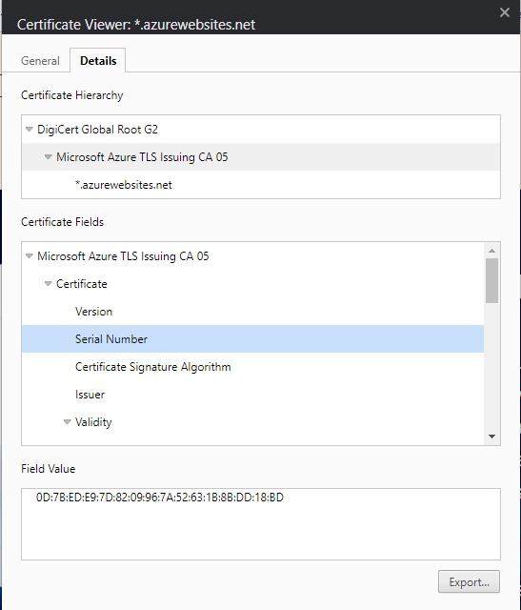

|  |
| --- |

* 1. List one other root CA in your browser’s root store.

| Another root CA in my browser’s root store is GlobalSign. |
| --- |

## Day 3 Questions

### Cloud Security Questions

1. What are the similarities and differences between Azure Web Application Gateway and Azure Front Door?

| Front door is non-regional and the Gateway is regional. |
| --- |

1. A feature of the Web Application Gateway and Front Door is “SSL Offloading.” What is SSL offloading? What are its benefits?

| SSL offloading is the process of relieving the web server from the duty of removing SSL encryption from incoming traffic. This allows the web server more resources to do other processes. |
| --- |

1. What OSI layer does a WAF work on?

| WAF works on layer 7. |
| --- |

1. Select one of the WAF managed rules (e.g., directory traversal, SQL injection, etc.), and define it.

| An SQL injection rule statement looks for malicious sql requests that attackers use to take advantage of your website for a variety of reasons such as gaining access to your database. |
| --- |

1. Consider the rule that you selected. Could your website (as it is currently designed) be impacted by this vulnerability if Front Door wasn’t enabled? Why or why not?

| Yes, the website would/could be impacted by this vulnerability due to having Front Door disabled, makes a website vulnerable to attacks such as SQL injection. |
| --- |

1. Hypothetically, say that you create a custom WAF rule to block all traffic from Canada. Does that mean that anyone who resides in Canada would not be able to access your website? Why or why not?

| No, using a WAF rule to block all Canadian traffic would not completely block people in Canada from accessing the website. While the WAF rule would block IP addresses originating from Canada, it is not actually possible to know whether the user accessing the website is actually located in Canada. An example of this would be, if someone tried accessing the website from a Canadian IP address in a different country, they would be blocked even though they are not technically in Canada. Users in Canada could also use a VPN to mask their IP address which bypasses the WAF rule allowing them access to the website. |
| --- |

1. Include screenshots below to demonstrate that your web app has the following:
   1. Azure Front Door enabled

|  |
| --- |

* 1. A WAF custom rule

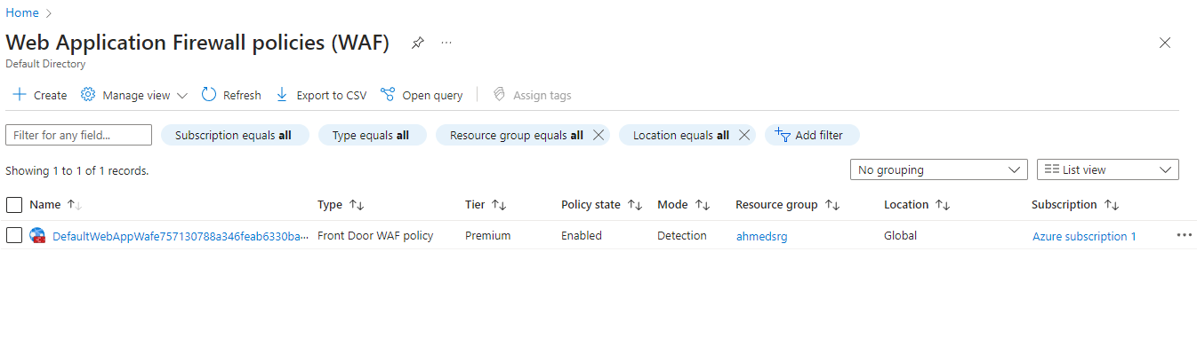

|  |
| --- |

## Disclaimer on Future Charges

Please type “**YES**” after one of the following options:

* ***Maintaining website after project conclusion****: I am aware that I am responsible for any charges that I incur by maintaining my website. I have reviewed the* [*guidance*](https://docs.google.com/document/d/1ZzC4oTJFdlkkeWuzuJAyVSqtDFbuAWilmwXg8PZgzMs/edit) *for minimizing costs and monitoring Azure charges.*

**YES**

* ***Disabling website after project conclusion****: I am aware that I am responsible for deleting all of my project resources as soon as I have gathered all of my web application screen shots and completed this document.*

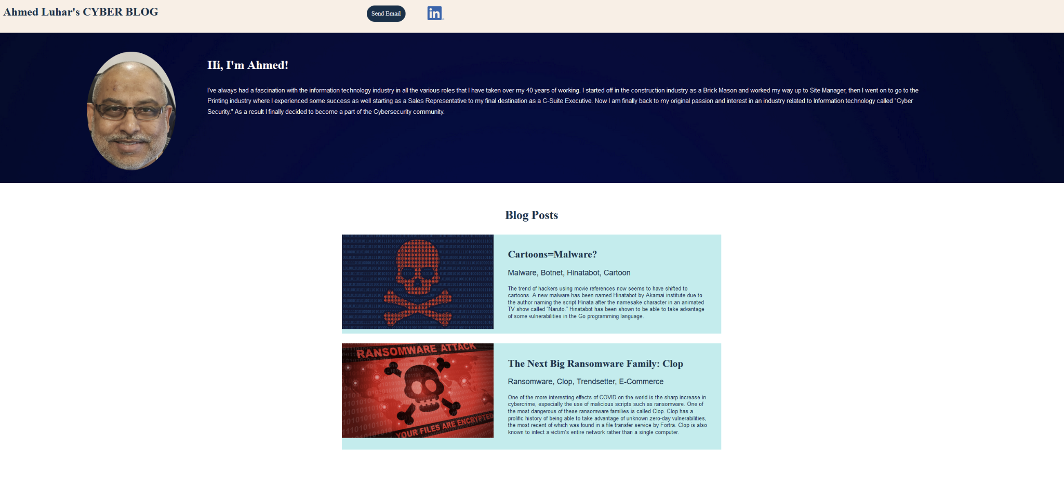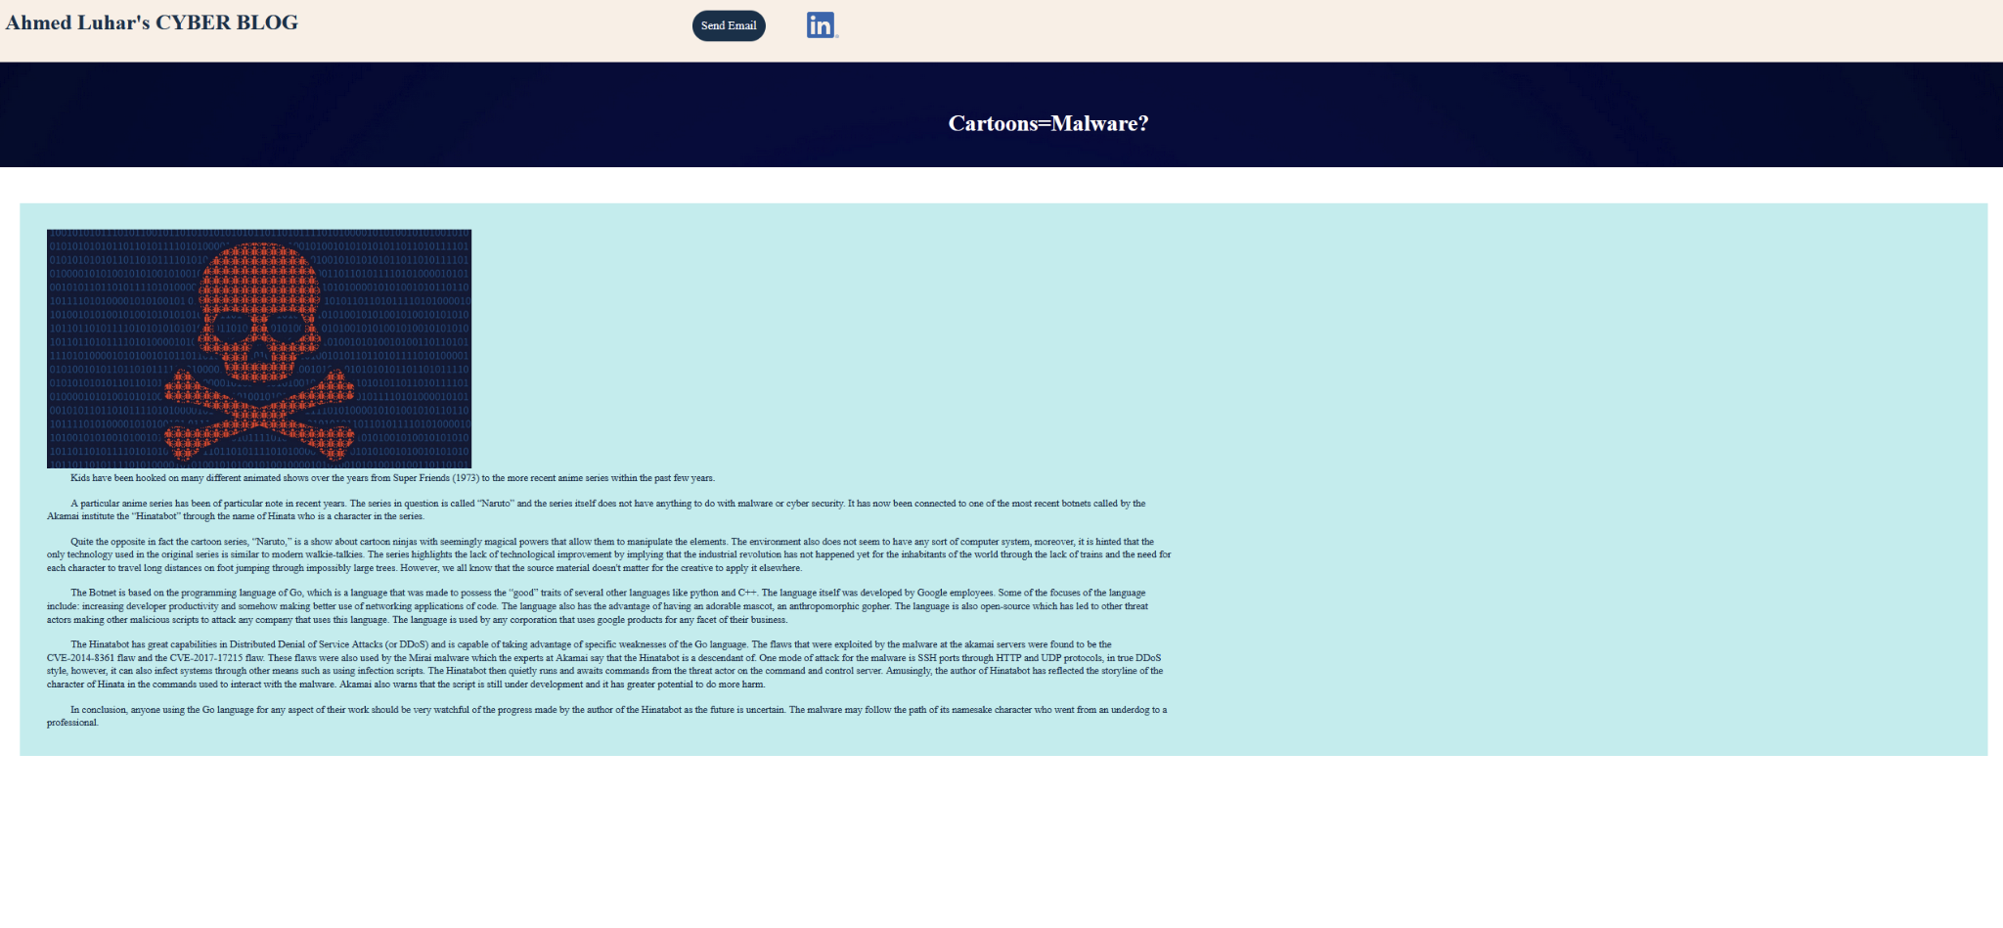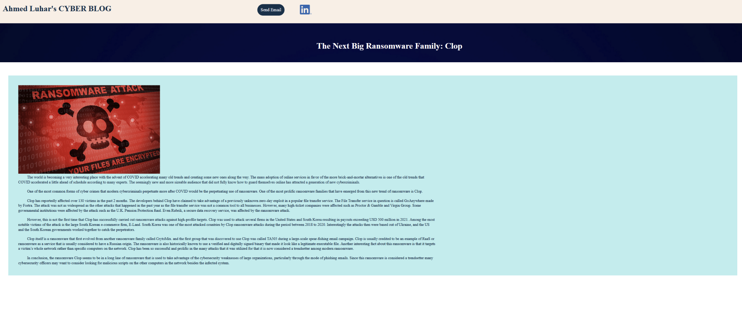

© 2022 Trilogy Education Services, a 2U, Inc. brand. All Rights Reserved.